QARSHI TIBBIYOT  TEXNIKUMI |  | QARSHI MEDICAL  COLLEGE

S E R T I F I KA T
QT L&P № 0000001
ABDIXAKIMOVA FAYOZA KAMOL QIZI
Qarshi Tibbiyot Texnikumida 23.03.2026 yildan 13.06.2026 yilgacha 360 soat
FARMATSIYA
Kasbi bo’yicha (tayyorlash, qayta tayyorlash va malakasini oshirish) kursini to’liq tamomladi
From 23.03.2026 to 13.06.2026 year 360 hours completed full professional course of
PHARMACY
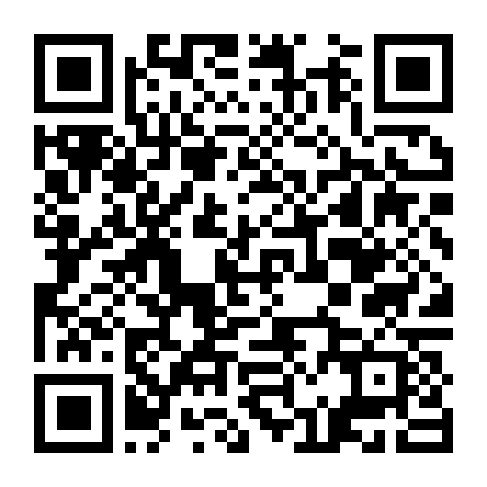
In Qarshi Medical College

Director Asraliyev Asomiddin Fayzullayevich Ro’yxatga olish raqami: 0000001
(Director) (Registration number)

Izoh: Ushbu sertifikat O'zbekiston Respublikasi Prezidentining 2020-yil 11-avgustdagi PQ-4804-son Qaroriga asosan o'rta maxsus, kasb-hunar ta'limi diplomi darajasiga tenglashtirilgan va egallagan bilimlarni mehnat faoliyatida amalga oshirish huquqini beradi, biroq ta'limning keying turini davom ettirish uchun asos hisoblanmaydi.

